How to add Shared Mailbox on o365 web mail

1. Login o365 account and find FOLDER

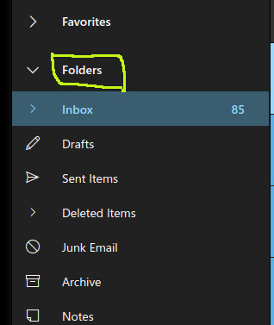

2. Right click --- Add shared folder

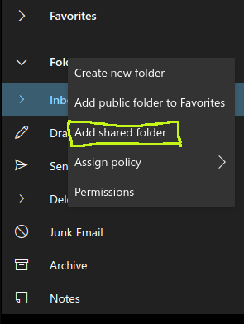

3. Enter the shared mailbox email ID

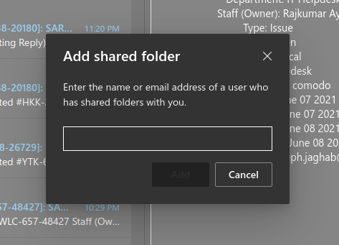

4. It will take few min to reflect on your o365. It will create a separate Inbox and Sent items.

5. In order to send mail from shared mailbox ID. Click new message – Click three dots – Click Show From.

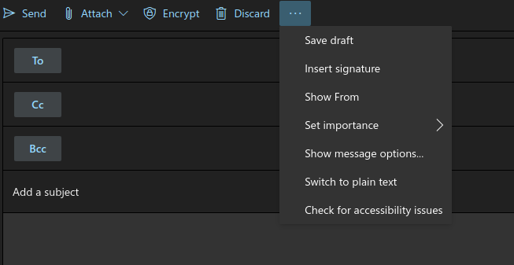

6. Click Other email address and enter your email.

